**Software Document Specification (SDS)**

BOOK IT

Blockchain Based Online Ticketing System

**Version 1.0**

|  |  |
| --- | --- |
| Project Code | F20-031 |
| Supervisor | Dr. Faisal bin Ubaid |
| Co-Supervisor |  |
| Project Manager | Muhammad Faizan |
| Project Team | Muhammad Faizan  Arsalan Ashraf  Saad Ahmed Raja |
| Submission Date |  |

Table of Contents

1. Introductionto Design Document 3

1.1. Purpose of Project 3

1.1.1. Enhanced Transparency 3

1.1.2. Improved Security 3

1.1.3. Modernized Ticketing Process 3

1.1.4. Reduced Costs and Fraud 3

1.1.5. Efficient Record Keeping 3

1.1.6. Seamless Integration 3

1.1.7. Scalability 3

1.1.8. User Accessibility 3

1.2. Document Overview 4

2. Entity Relationship Diagram 5

3. Sequence Diagrams 6

3.1. Sign Up Sequence Diagram 6

3.2. Admin Sequence Diagram 7

3.3. User Sequence Diagram 8

4. Architecture Design Diagram 10

5. Test cases 11

6. User interface design 13

6.1. Home Page 13

6.2. Sign Up or Login page 14

6.3. About 15

6.4. Contact US 16

# Introductionto Design Document

## Purpose of Project

Project Purpose Statement for Block-chain based Online Bus Ticketing System:

The purpose of this project is to design, develop, and implement a secure and efficient Block-chain based online bus ticketing system that aims to revolutionize the way bus transportation services are managed and accessed. This system will leverage Block-chain technology to enhance transparency, security, and convenience in the bus ticketing process while addressing the following key objectives:

* + 1. Enhanced Transparency: The project seeks to establish a transparent and tamper-proof ledger that records all ticketing transactions and bus schedules. By doing so, it will enable passengers, bus operators, and regulatory authorities to have real-time access to reliable information, reducing the potential for fraud, disputes, and misinformation.
    2. Improved Security: The Block-chain infrastructure will provide a robust and decentralized security framework, protecting sensitive passenger information, payment data, and ticketing records. The system will employ cryptographic techniques to ensure that data remains private and unaltered throughout the ticketing process.
    3. Modernized Ticketing Process: The project aims to simplify the bus ticketing process for both passengers and bus operators. Through the implementation of a user-friendly interface, passengers will be able to book and manage their tickets seamlessly, while bus operators can efficiently manage schedules and passenger data.
    4. Reduced Costs and Fraud: By reducing the need for intermediaries, the Block-chain based system will lower operational costs for bus operators and minimize the risks associated with fraudulent activities such as ticket scalping and counterfeit tickets.
    5. Efficient Record Keeping: The Block-chain ledger will serve as a permanent and immutable record of all ticketing transactions. This historical data can be leveraged for performance analysis, reporting, and auditing, benefiting both bus operators and regulatory authorities.
    6. Seamless Integration: The project will focus on compatibility and interoperability, ensuring that the Block-chain based ticketing system can seamlessly integrate with existing transportation infrastructure, such as ticketing machines, mobile apps, and other relevant technologies.
    7. Scalability: As the transportation system expands, the Block-chain based solution will be designed with scalability in mind, accommodating the growing number of passengers, routes, and operators.
    8. User Accessibility: Accessibility will be a key consideration, making the system user-friendly for passengers of all backgrounds and abilities. This will be achieved through intuitive interfaces, multi-language support, and accommodating various payment methods.

In summary, this project aims to leverage Block-chain technology to create a secure, transparent, and user-friendly online bus ticketing system that will benefit both passengers and bus operators. By achieving these objectives, we intend to foster trust, efficiency, and convenience within the bus transportation industry, ultimately enhancing the overall travel experience for all stakeholders.

## Document Overview

This Software Design Specification (SDS) outlines the comprehensive design and architectural details of the Block-chain Based Online Bus Ticketing System. The document serves as a blueprint for the development team and stakeholders involved in the project, offering insights into the system's structure, components, and functionalities. By providing a clear and in-depth understanding of the software's design, this document aims to facilitate effective development, testing, and implementation.

# Entity Relationship Diagram

Database data models are designed using an ER diagram. Creating an ER Diagram aids in doing crucial due diligence to identify and record system needs when creating a new data model. An ER diagram serves as a reference during production to increase database throughput, solve issues and helps to redesign architecture. Figure 1 illustrates the entity relationship diagram of Block-chain based online ticketing system, which includes all the associated entities and their relationships in the system.

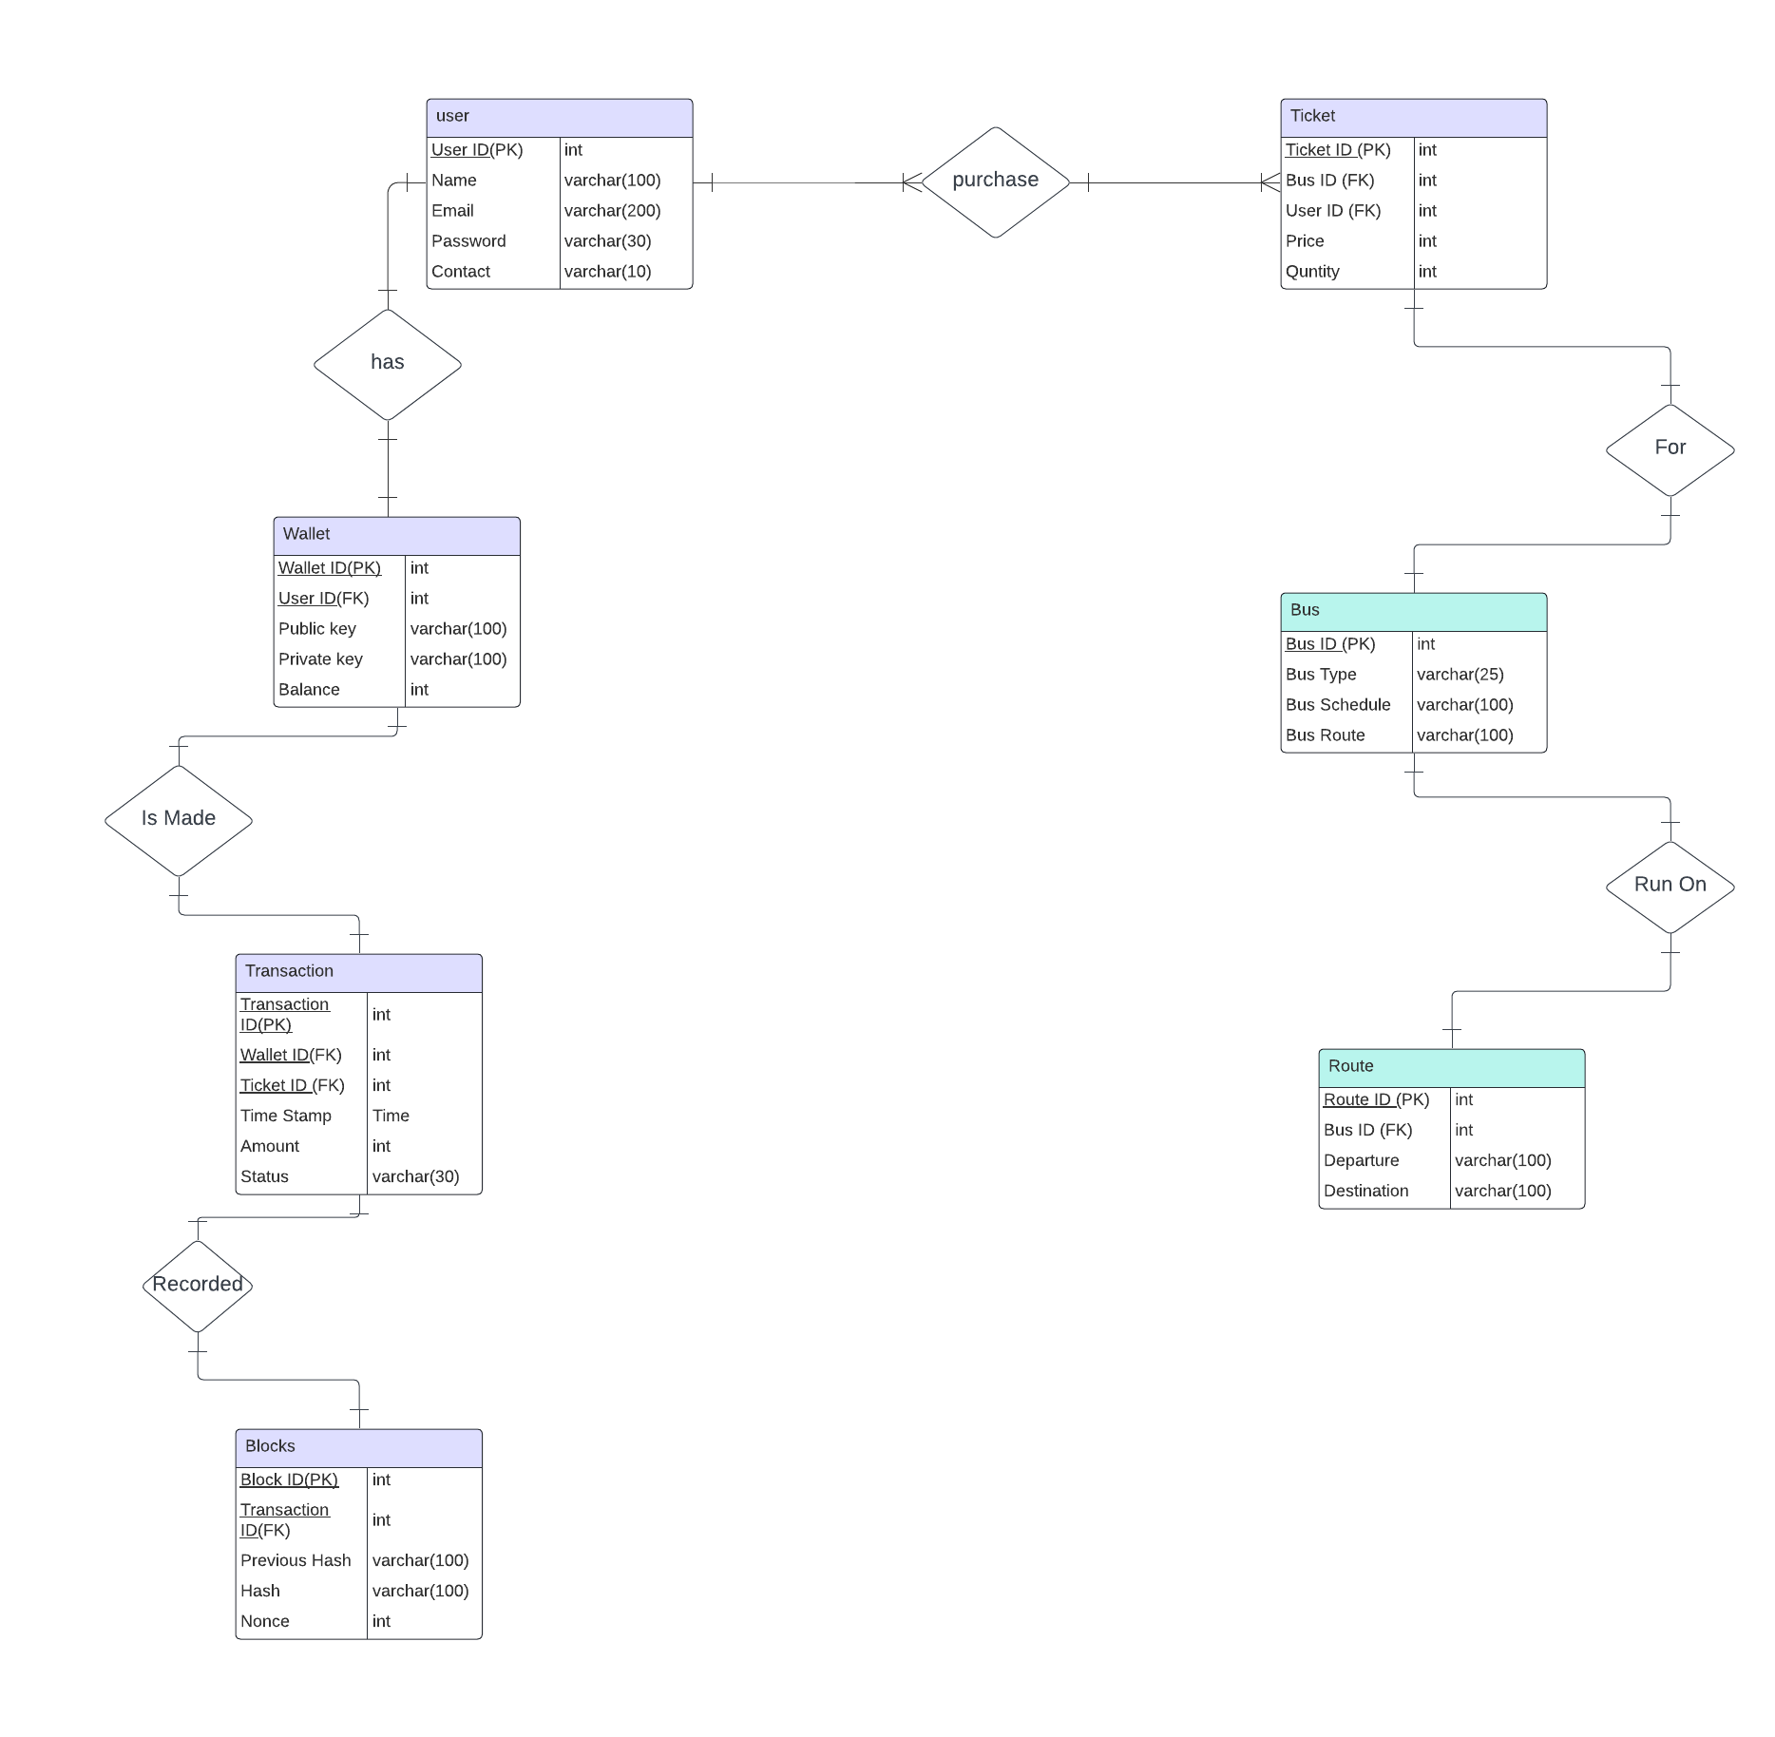

Figure 1 Entity Relationship Diagram

# Sequence Diagrams

Sequence diagram describes about the interactions between objects or components in a system. It is used to represent the dynamic behavior of a system and to model the interactions between objects in a sequential manner, showing the order in which messages are sent and received.



## Sign Up Sequence Diagram

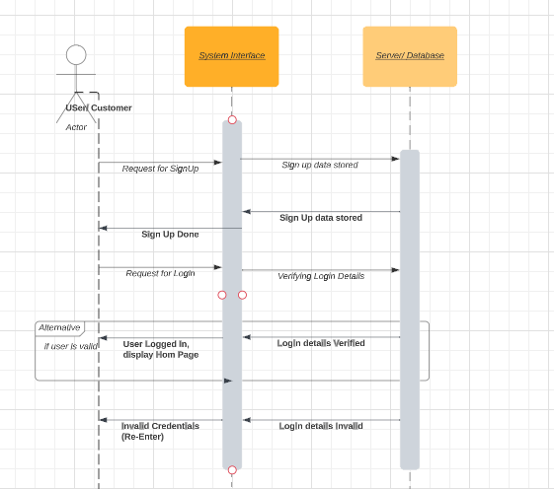

## Admin Sequence Diagram

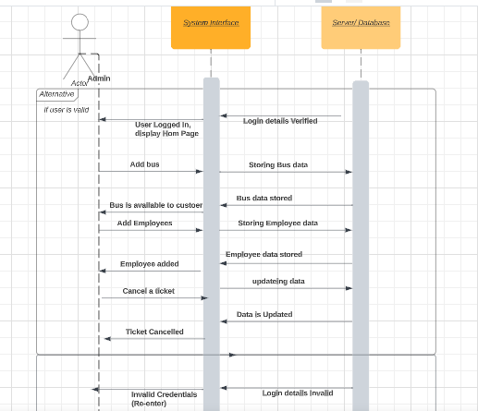

## User Sequence Diagram

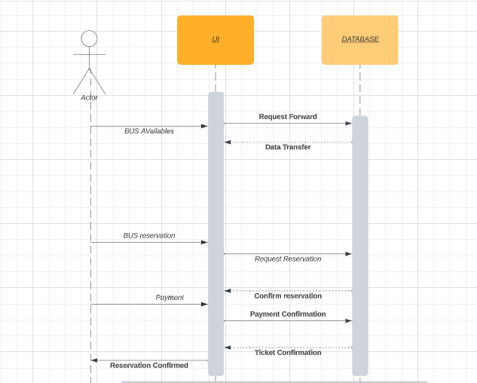

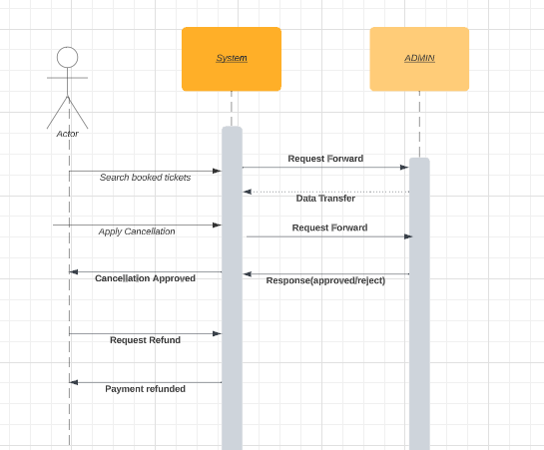

## 

# Architecture Design Diagram

The website is mainly based on three tier architecture frond-end mid-tier back end. The front end is made by using React The mid-tier covers the core logic of website where the 3d portion is covered by using three.js library. The back end is to connect the front end and the mid-tier where the website has used node js and to store the data, we will be using mongo dB /firebase.

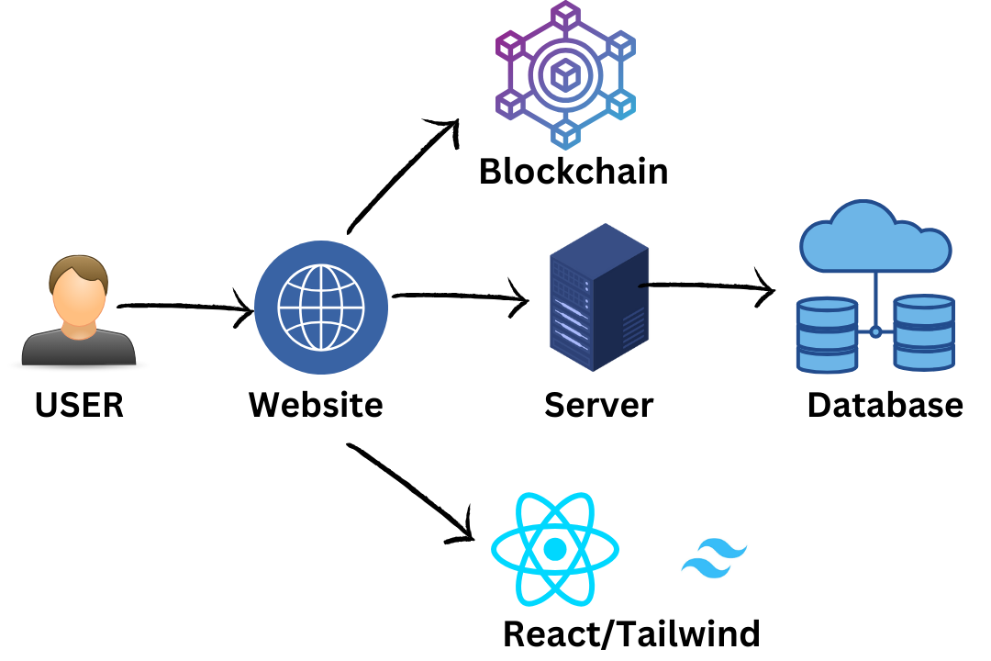

Figure 3 Architectural diagram

The class diagram of Block-chain based online bus ticketing system is shown in Figure 4. All the classes associated with our system and their relationship are also defined in this diagram.

# Test cases

|  |  |  |  |  |  |
| --- | --- | --- | --- | --- | --- |
| Test Case  Id | Feature | Test Case Description | Steps to Execute | Input Data | Expected Result |
| 1 | Functional | Verify the Customer that will be able to login to system | Customer will provide its Email and password | Email and password | Customer will be accessed into the system |
| 2 | User Interface | Check all the fields like text boxes, radio buttons, Dropdown buttons, etc. | Click on Buttons | N/A | UI should response correctly |
| 3 | Phone Number validation | Check the phone number length if length is not valid then it rejects | Enter number in correct format | Enter number | User will be registered in the system. |
| 4 | Email validation | Check the email in correct format | Enter Valid Email | Test@gmail.com | validated email should be displayed |
| 5 | Password validation | Check the password length and password should be alpha numeric | Enter password | Test123@ | Pop up Success Message |
| 6 | Internet Connection | Check The Internet connection | When user want to use service | As the Application start it will auto detect | Popup whether it connected or not |
| 7 | New user registration | Check user is already registered, if not then register | Fill out the user details in the form | Email address of user | Show the Error or success message. |
| 8 | User Access | Check whether user is logged in to use Website | When user want to access to any function which requires user login | Check the user specific token is available , if available then check the validity | Allow user to use the Website |
| 9 | Reserve a Ticket | Check whether the user has opt select the bus/time | Search and then select the bus/time | Search Criteria and Payment | Allow user to reserve the ticket |
| 10 | Download and view ticket | Check whether the user has Completed the payment or not | Click on download button to download and view button to view the ticket | Fulfil the payment requirements to download/view the ticket | Ticket will be confirmed and is downloadable |

# User interface design

## Home Page

The homepage of online ticketing system typically serves as the first point of contact for visitors and should provide a clear and concise overview of the system. Here is the screenshot of home page

* An image: A high-quality image that showcases the system's work or the types of projects they specialize in.
* Navigation Menu: A clear and easy-to-use navigation menu that directs visitors to key sections of the website, such as Home, portfolio, login, or pricing

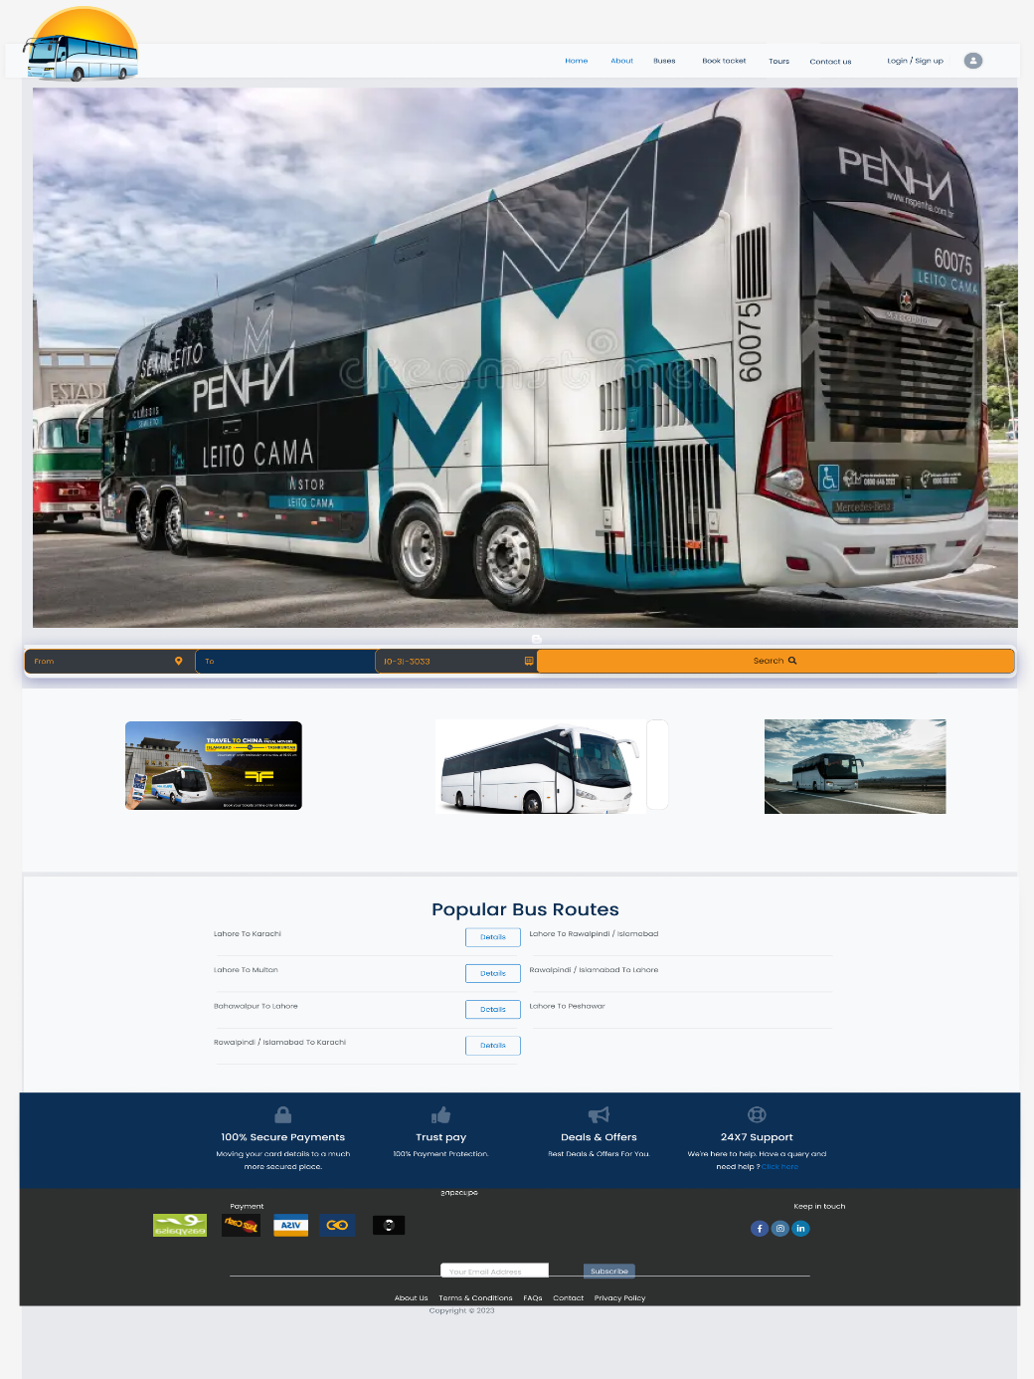

## Sign Up or Login page

A signup page is a crucial part of any website that requires users to create an account to access certain features or services. Here are some key elements to find on a signup page:

* Form Fields: The signup form should include all the necessary fields, such as name, email address, password, and any other relevant information required for account creation.
* Password Strength Indicator: It can be helpful to include a password strength indicator to encourage users to choose a strong password to keep their account secure.

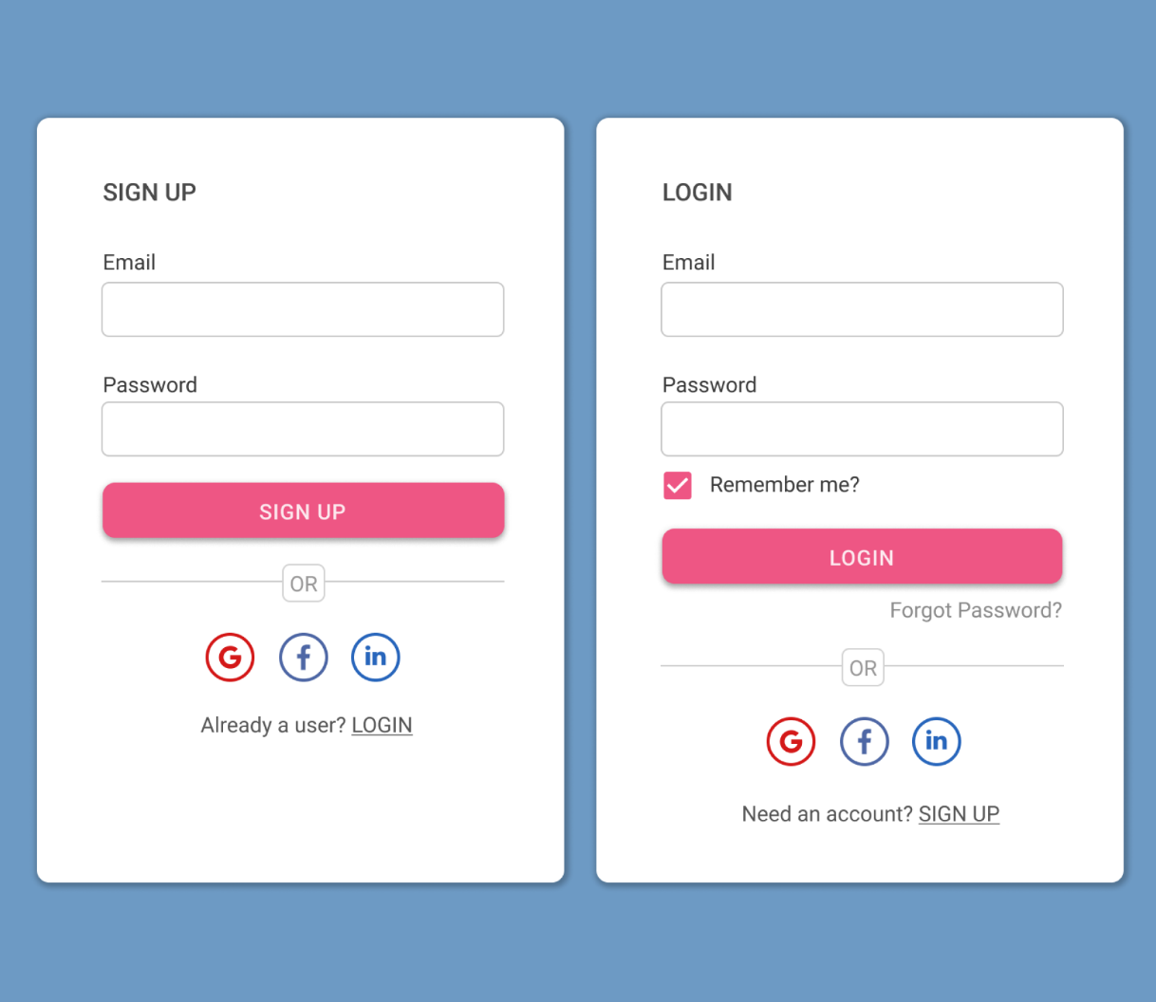

## About

A about page with images is a great way to describe what is the project all about and provide visual examples of your design skills. Here are some key elements to include:

* 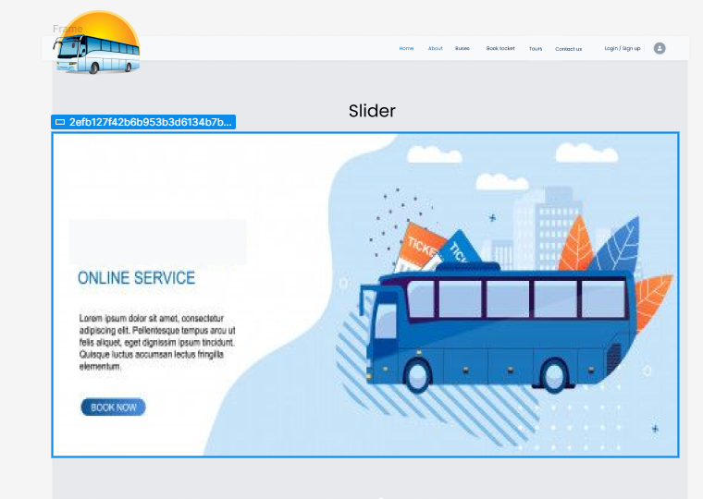Navigation: Make it easy for users to navigate between different projects by including a clear and intuitive navigation system, such as a menu or thumbnails that users can click on to view each project.

## Contact US

A contact page on online ticketing system provides a space for customers to connect with technical team or with the company, it helps the company to build trust and credibility with potential clients. Here are some key elements to include:

* Text: Allow users to provide Name, Email and an additional message by including a text field where they can enter with what they need help.
* 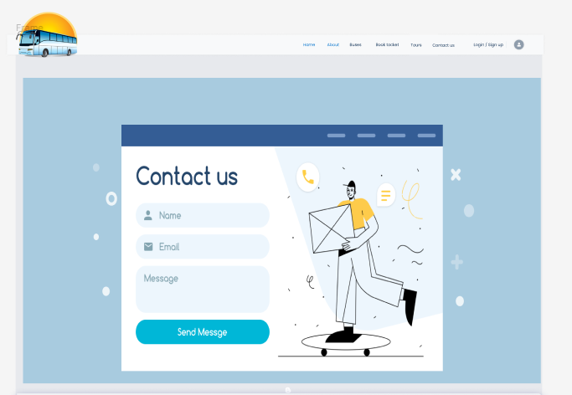Submit Button: Include a prominent "submit" button that users can click to submit their feedback.